1. Make a dataset (Using SQL) named “*daily_logins*” which contains the number of logins on a daily basis

select * from login_log;

Select Day(Day) as login_day, count(Day) as num_logins from login_log Group by Day order by login_day asc;

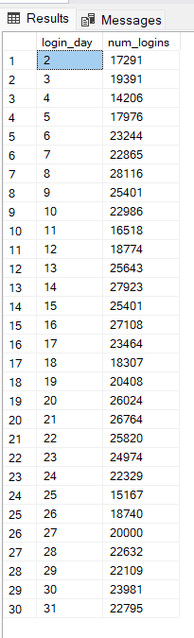

1. A. Daily trend of logins and

Select Day(Day) as login_day, count(Day) as num_logins from login_log Group by Day order by login_day asc;

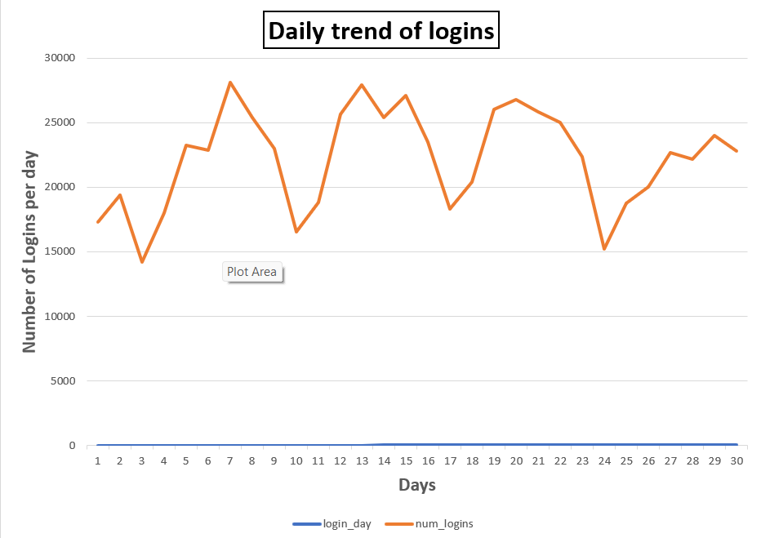

1. Trend of conversion rate (Number of orders placed per login)

SELECT fk_buyer_id,

COUNT(order_id) AS order_count

FROM sales_order

GROUP BY fk_buyer_id

Order by order_count;

**The conversion rate is 2.8%**

1. Prepare a report regarding our growth between the 2 years. Please try to answer the
2. Did our business grow?

Our business is growing because of each customer is buying one or more product from the app

1. Does our app perform better now?

c. Did our user base grow?

select * from login_log;

select Day, count(user_id) as Total_users

from login_log

group by Day order by Day asc;

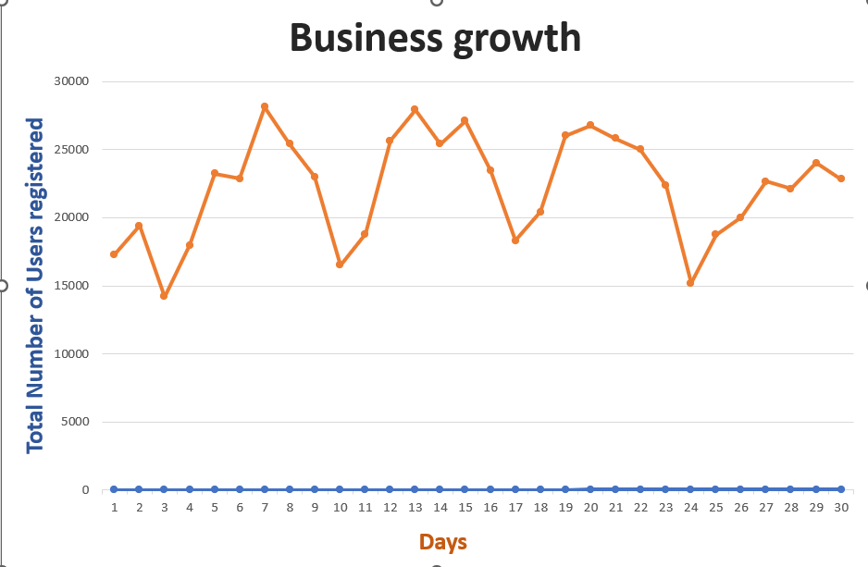

1. What are our top-selling products in each of the two years? Can you draw some insight from this?

select * from sales_orders_items;

select fk_product_id, count(fk_order_id) as Total_orders

from sales_orders_items

group by fk_product_id order by Total_orders desc;

1. Looking at July 2021 data, what do you think is our biggest problem and how would you recommend fixing it?

select * from sales_order;

select count(sales_order_status) as Rejected_Orders

from sales_order

where sales_order_status like 'Rejected';

